[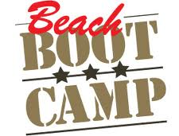](http://www.google.co.uk/imgres?q=beach+bootcamp&hl=en&qscrl=1&nord=1&rlz=1T4ADRA_enGB452GB453&biw=1366&bih=540&tbm=isch&tbnid=MPI4-YhrotIjsM:&imgrefurl=http://rebornpt.wordpress.com/&docid=tZ6CKQfelU2kJM&imgurl=http://rebornpt.files.wordpress.com/2012/01/beachbootcamp.jpg&w=282&h=214&ei=7bNkT9HcO82F8gPyy9SzCA&zoom=1)

**Charity**

[](http://www.google.co.uk/imgres?q=st+oswald%27s+hospice+newcastle&hl=en&sa=X&qscrl=1&nord=1&rlz=1T4ADRA_enGB452GB453&biw=1366&bih=540&tbm=isch&prmd=imvns&tbnid=c5H-6yuK8LRXRM:&imgrefurl=http://www.activenewcastle.co.uk/friends/view/st-oswalds-hospice/&docid=25v5sd7zH8_iFM&imgurl=http://www.activenewcastle.co.uk/images/gckb6j.jpg.jpg&w=292&h=292&ei=b7VkT57BCcWi8QOhyoiOCA&zoom=1)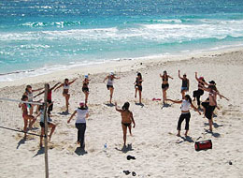

**Come & have some Fitness Fun on the beach. All for a great cause.**

**Saturday 28th April**

**10:00 – 12:00**

**2 Personal Trainers**

**Seaton Sluice Beach**

(meet in car park up from the Astley Arms towards round a bout)

**£10pp All to St Oswald’s**

**Call Laura to book 07921141036**

**Email:-** [**laurasbootcamps@mail.com**](mailto:laurasbootcamps@mail.com)